**NAT GATEWAY**

INSTANCE CREATED:

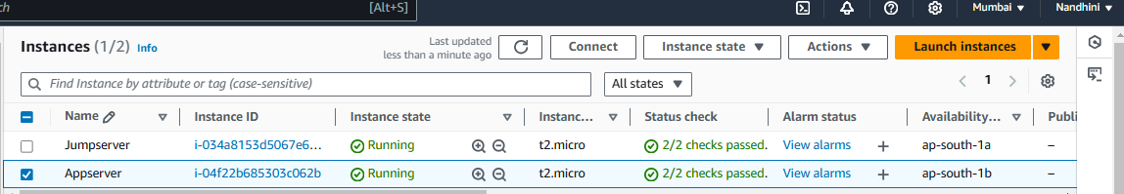

VPC:

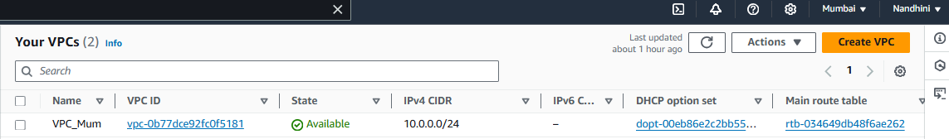

PUBLIC & PRIVATE SUBNET:

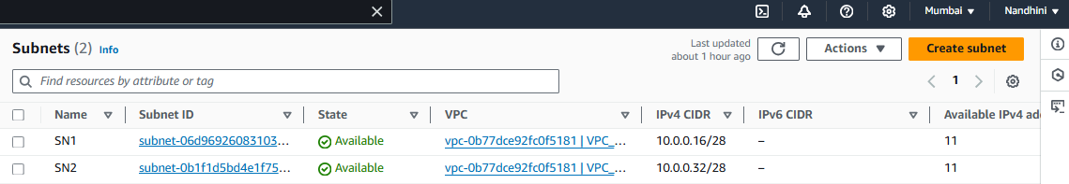

ROUTE TABLE:

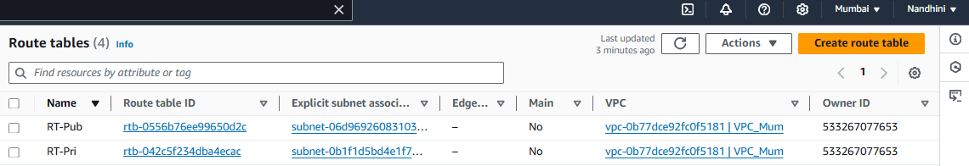

INTERNET GATEWAY:

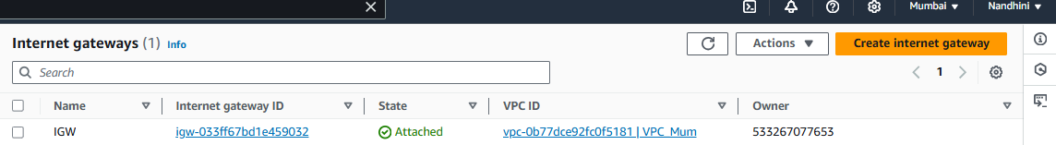

Associated Public subnet and edit routes with IGW:

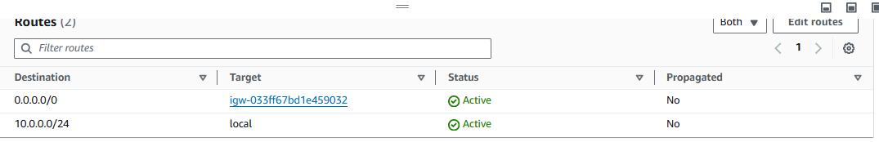

**NAT GATEWAY:**

NAT gateway: Enables instances in a private subnet to send outbound traffic to the internet.

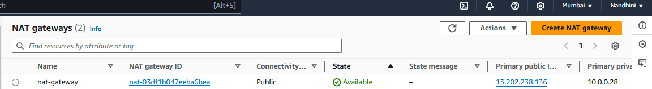

Associated Private subnet and edit routes with NAT-GATEWAY:

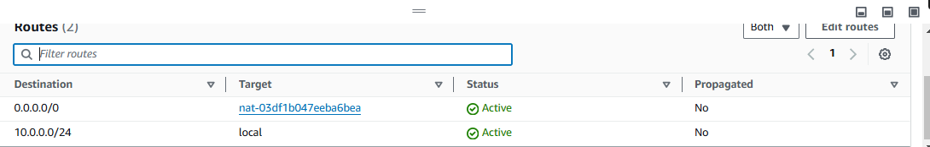

Generated private key to access server through PUTTY GEN:

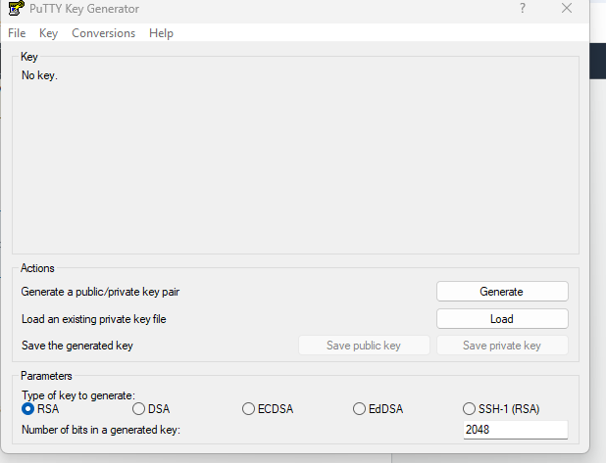

Accessing jumpserver using PUTTY GEN:

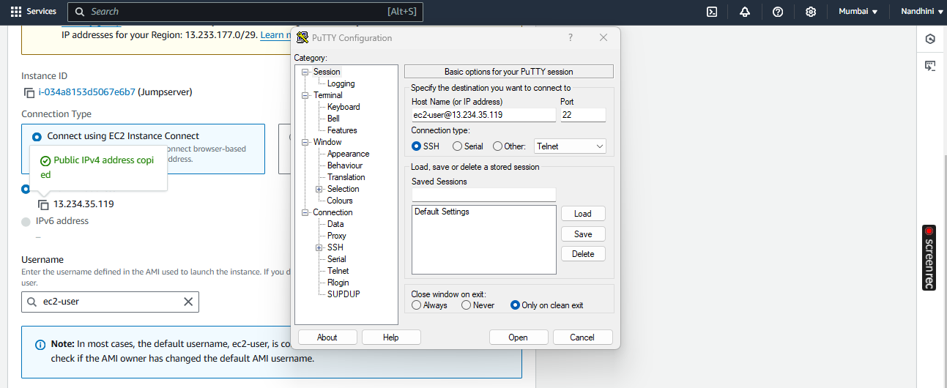

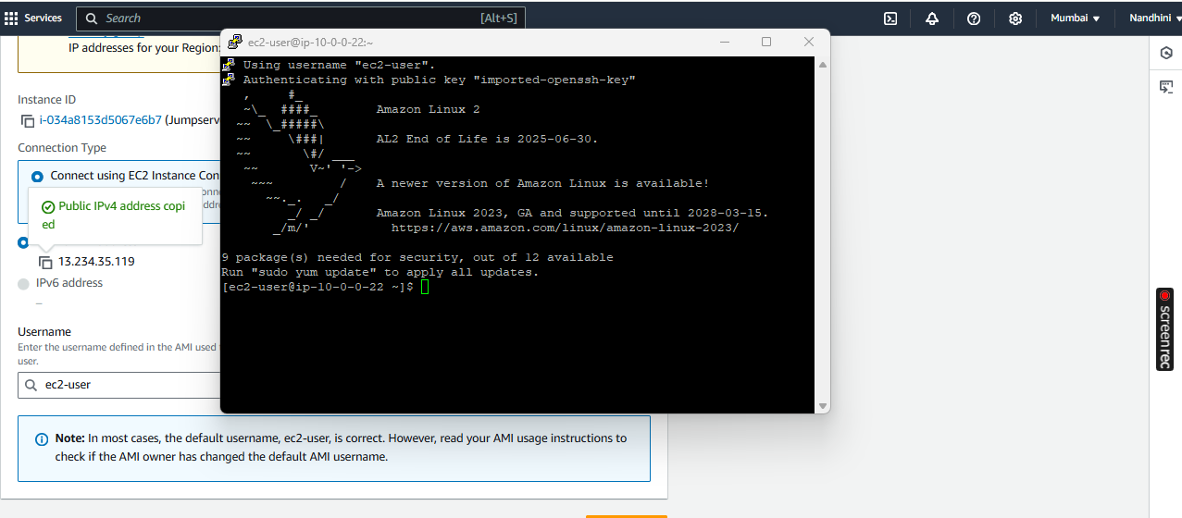

Checking internet connection for Jumpserver:

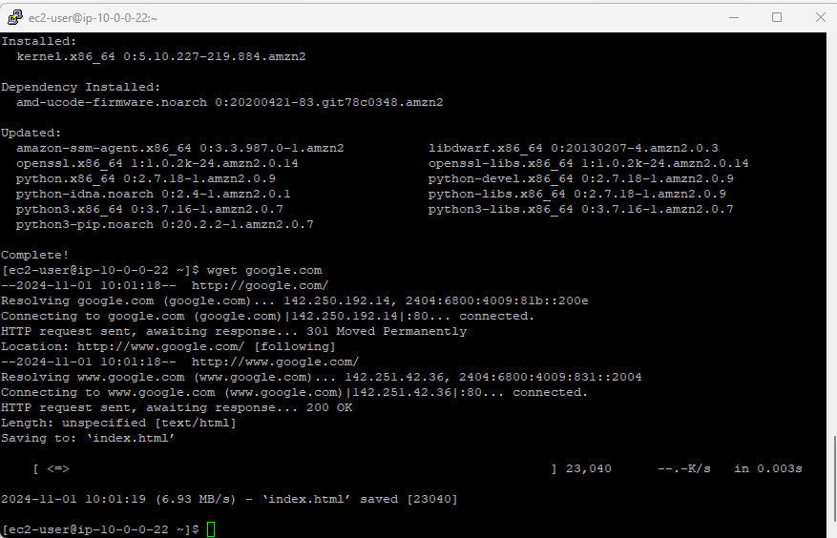

Trying to switch from Jumpserver to Appserver: Permission denied.

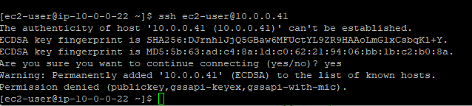

Permission provided:

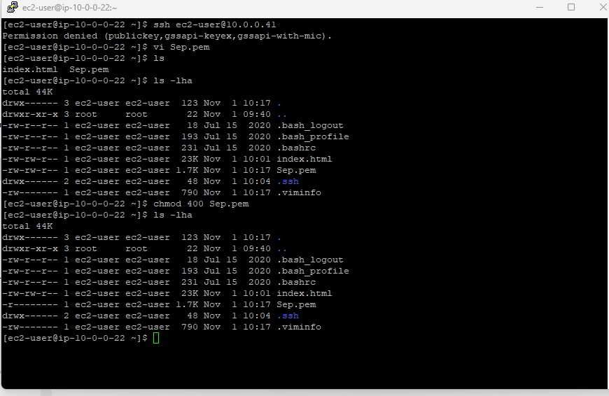

Successfully switched from Jumpserver to Appserver:

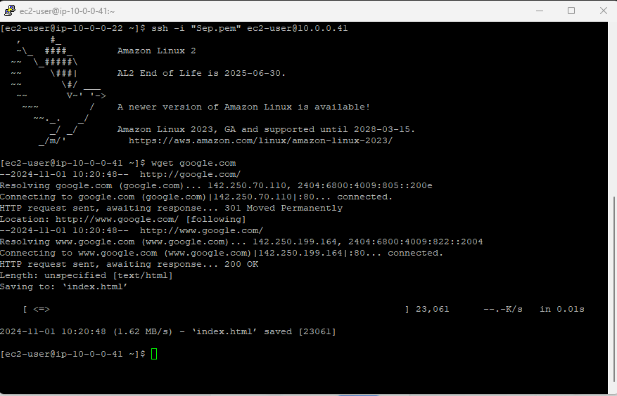

Checked internet connection to Appserver by installed JAVA.

